BY, R.HARISH BABU

HOBBY APP

AIM:

Create a hobby app design in figma.

PROCEDURE:

1. Open Figma and create a new file.

2. Create a frame for your app’s layout, using a common size like 375 x 812 pixels.

3. Design the main screen with an overview of tracked hobbies, such as progress charts and recent activities.

4. Add navigation for accessing different hobbies, entries, and settings.

5. Create detailed screens for tracking individual hobbies with input fields for logs, milestones, and notes.

6. Include a profile or settings page for user preferences and app configurations.

7. Style the design with consistent colors, icons, and fonts. Set up interactions for navigating between screens.

8. Review, export assets if needed, and share the design for feedback.

RESULT:

A hobby tracking app design featuring an overview screen, detailed hobby tracking pages, and a settings page, all styled and interactive.

DESIGN:

FIRST PAGE:

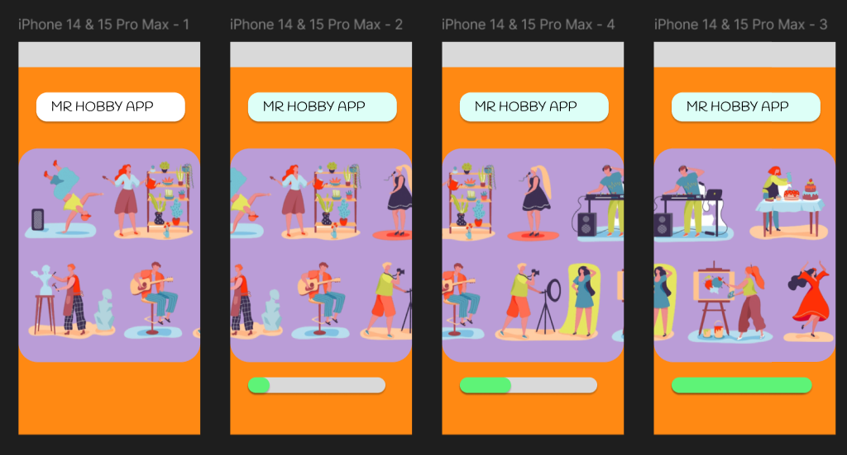

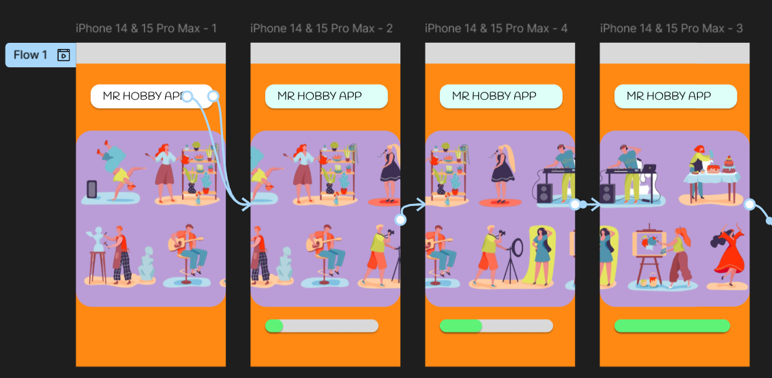

MAIN PAGE:

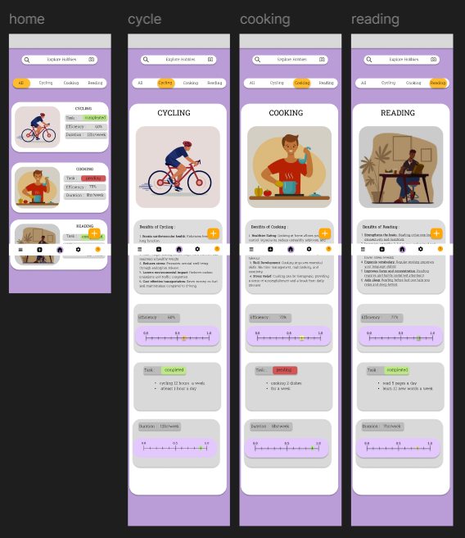

FULL DESIGN:

